TIME SERIES DATA ANALYSIS AND FORECAST METHODS

Lecture 8
Time series forecast with autoregressive models

Yekaterinburg
2017
Contents

Lecture purpose 3

Lecture map 3

Part 1. Forecast with ARMA and ARIMA models 4

Part 2. Example of the forecast with AR model 8

Part 3. Forecast correction with new observations 10

Part 4. Estimation of the confidence interval for the forecast 13

References 16

Lecture purpose
The purpose of this lecture is to form concepts and skills in the field of forecasting of time series based on AR, MA, ARMA and ARIMA models. All of the theoretical approaches are demonstrated with some descriptive examples. Besides, during the lecture correction methods for the forecast with the help of new observations, and also methods for the formation confidential intervals are studied.

Lecture map

- Basic forecast from ARMA model
- Example of retrospective forecast with AR model
- Correction method for ARMA models based on new observations
- Example of corrections with new observations
- Estimation of confidence intervals for forecast
- Example of confidence interval reconstruction for an ARMA model forecast

Part 1. Forecast with ARMA and ARIMA models
Earlier we considered the models of TS (time series) presented in the form of processes of autoregressive – moving average (ARMA) model. The concept of autoregressive (AR) defines that the current observation is just a combination of previous observations. In case of processes of the moving average (MA), the current observation is a result of a combination of random disturbances. In both cases between the previous and subsequent data of TS there is some functional dependence therefore the ARMA models are ideal for the forecast of TS.
The most important when forecasting is to achieve as much accuracy as possible, that is to minimize a forecast error. As it was specified earlier, the forecast error can be described by different values. In case of the ARMA and ARIMA models we will be interested in the forecast with the minimum root mean-square error.
Note that in a general view the ARIMA model is expressed as:

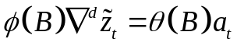 (8.1)

The ARIMA model can be reduced to the ARMA model through the difference scheme, for the forecast we consider that this scheme has been already made and the basic model for the forecast is on a basis:

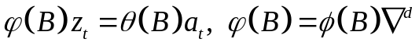 (8.2)

Let us predict observation 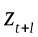 starting from the moment t. It means that the forecast is made at the moment t with prediction l.
The general ARMA model (8.2) can be represented in three forms:
- Through difference equations:
(8.3)
- According to Wold theorem, any ARMA = MA(∞), meaning it is possible to write a forecast model through the infinite weighed sum of the current and the previous impulses 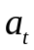:
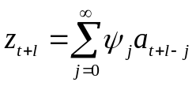 , (8.4)
where weighting coefficients 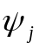 can be found from the known polynomial equation 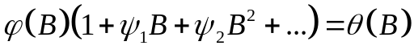.
- According to the principle of a mutual reversibility of properties between AR and MA models, the forecast model can be written through the infinite weighed sum of the previous observations:
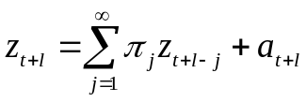 (8.5)
From three of these forms the first method of creation of the forecast is the simplest computationally implementable and much more simple for understanding when put into practice. In the second and third form of representation everything is spoiled be the existence of «infinity» in calculations, complicating already bulky calculations. Therefore the scheme of forecasting we will consider only for the first form (8.3).
Now we will try to find such forecast 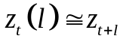 on the basis of model ARMA (8.2), which would be the best among all set of forecasts:
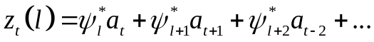 (8.6)
where 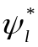 – the best found forecast weights.

Let's compare expressions (8.6) and (8.4); subtracting them from each other we can estimate the mean-squared error of the forecast:
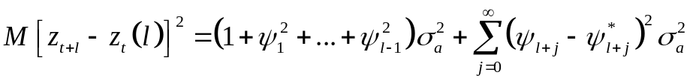. (8.7)
Where is the minimum of this function? Equation (8.7) is simple enough, thus, it is obvious that we need to have 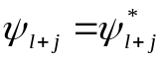. This output is a special case of more general outputs from the forecasting methods with the support of minimization based on mean-squared error.
As a result we receive:
, (8.8)
where we already know the second sum from (8.6), and the first sum we will designate as the error 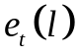.
Thus we will receive the expression for the forecast 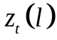 at prediction l with the forecast error :
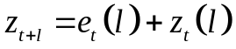.
Let's note, what we can describe with this forecast scheme. First of all, the forecast with the smallest root mean-squared error at the time of t with prediction l is the mathematical expectation value of at the moment t+l:
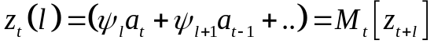 (8.9)
Equation we can call the forecast function at the moment t. Secondly, the forecast error with prediction l is equal to
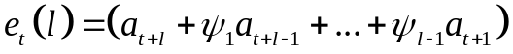. (8.10)
Error expectation value is zero 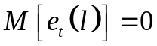, its variance is:
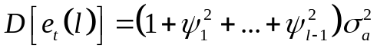. (8.11)

Thirdly, what if we construct the one-step forward prediction? Let's find the one-step forward error of the forecast:
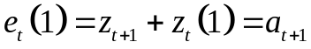. (8.12)
It turns out that the residual errors of initial process are the forecast errors on a one-step forward. At the same time we demanded values to have no correlation between each other. Therefore for the forecast with the minimum root mean square error the forecast error for a one-step forward has to be not correlated too.
That is obvious, if the forecast errors were correlated, then, having eliminated this dependence between them, we would receive even more exact forecast that contradicts initial problem definition about the best forecast with the minimum root mean square error. Meanwhile, though forecast errors with prediction “1” (one-step forward) are not correlated, for bigger steps this condition cannot be satisfied.
So, now we know what is required to us for the forecast with the minimum root mean square error: we need to find an expectation value of a random variable at the moment t.
Similarly for (8.5), (8.4), (8.3) we will denote three forms of submission of the forecast. In the form of a weighed mean:
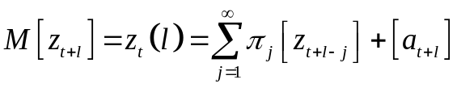 (8.13)
Integrated forecast:
(8.14)
As the difference equations:
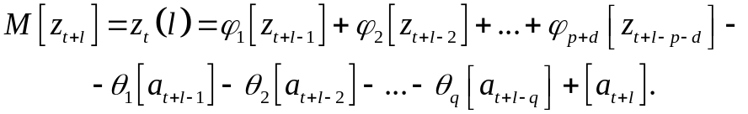 (8.15)
This form (8.15) is the best representation of the ARMA forecast, because it is the simplest for the implementation and estimation.

Part 2. Example of the forecast with AR model
Let there is some time series which observations are given to us, TS is given in the figure 8.1. After the analysis of properties of the TS it is established that this data is better described by the AR(2) model of the second order:
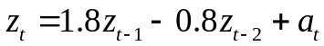 (8.16)
Values of the estimated model (8.16) are given in the figure 8.1 too.
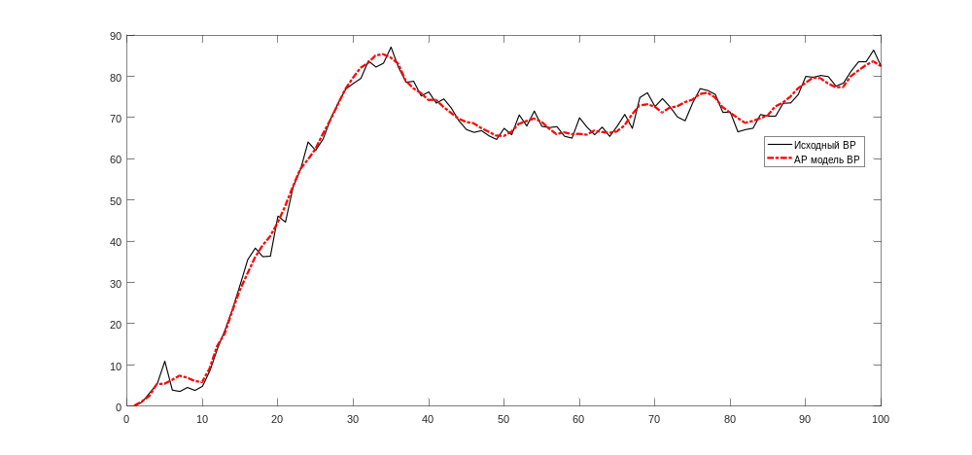
Figure 8.1 – Initial data (black) and its AR model (8.16)
We want to forecast this TS on several points forward, since some moment of t. For this purpose we use difference equation in a form (8.15). The forecast in that case is constructed recurrently, by one-step ahead.
Beginning from the moment of time t, one-step forecast is:
(8.17)
on the first step reliable previous values are known to us, and errors should not be correlated (thus meaning 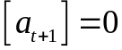).
On the second step of the forecast we consider again:
(8.18)
where we use the expression 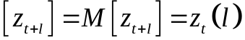 with zero error.
Similarly on the third step of the forecast we receive a reccurent formula for the time series forecasting:
(8.19)
As a result we receive the final scheme of the forecast, represented as:
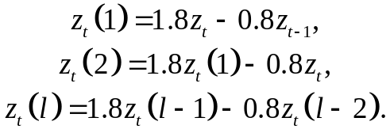 (8.20)
Let's construct the retrospective forecast for a given TS, from the 90th observation 10 steps forward. The result is given on figure 8.2 below.
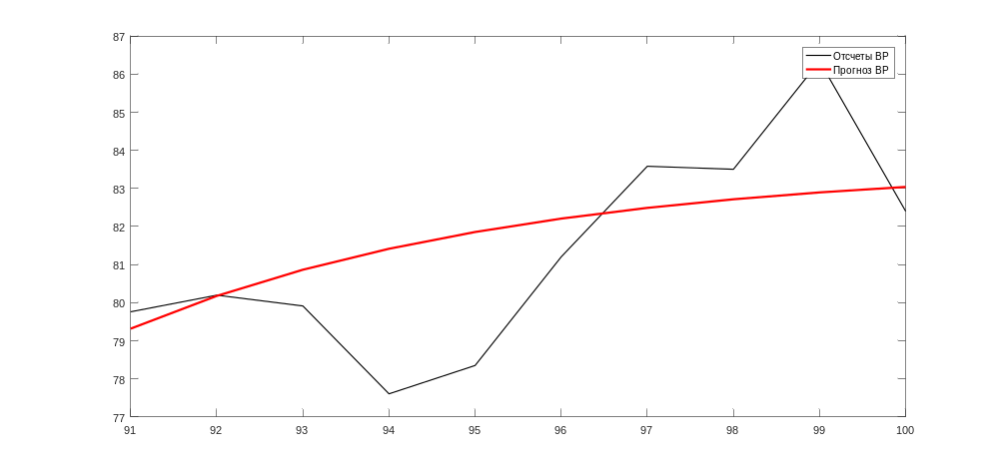
Figure 8.2 – Initial TS (black) and its retrospective forecast (8.20)
Apparently from the figure 8.2, in general the forecast turned out to be good (the average error of approximation is less than 20%). Inaccuracy of such forecast consists that on each step of the forecast we discarded unknown noise 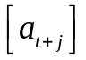, which in an initial row is not equal zero. However, we can improve this forecast with every new observation, thus making a forecast correction scheme.

Part 3. Forecast correction with new observations
In many cases the number of steps of the forecast predictions l is not so big, at the same time the scheme of the forecast is constructed recurrently (8.15). To find the confidence limits for these forecasts and to be able to calculate the new forecast corrections, we need to find the weights 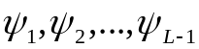. To solve this problem we can use the polynomial equation:
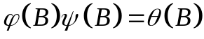. (8.21)
The coefficients on the polynomials of B must be equal, thus giving us the system of equations:
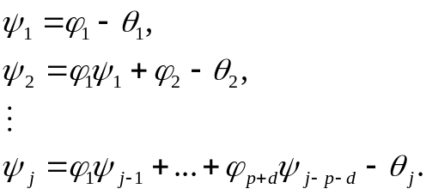 (8.22)
where 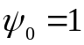;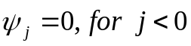;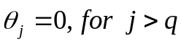.
This formula (8.22), in fact, is recurrent too and, therefore, weight factors 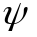 will be easy to calculate. How to use them specifically?
Let the forecast for one step be already executed, new true observation for correction is not known for now, and the forecast for one-step ahead is under construction as an additional step forward 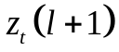. But if we knew this specific new observation at the moment of time t+1, then the more accurate forecast would be 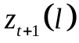 . Obviously, these two values are different, but how? Now we will find: let's rely at the same moment of time on the integrated form of the forecast (8.14):
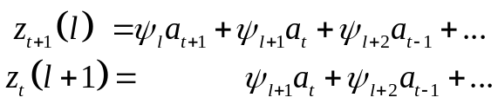 (8.23)
It turns out that the difference between these two forecasts consists only in one weight multiplier: 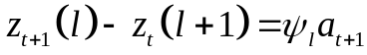.
From here also the scheme of correction of the forecast on the basis of weight factors and new observations appears. It looks as follows: for the forecast correction with every new observation it is necessary to find weight factors with the recurrent equation (8.22), and then to calculate new values of the predictions by means of expression:
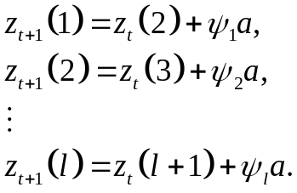 (8.24)
where a – the error between real and forecasted observation 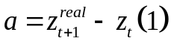. Thereby correction of the forecast for new observations will be executed.
Let's return to our forecast (8.20) on fig. 8.2. Let's estimate the necessary correction weights:
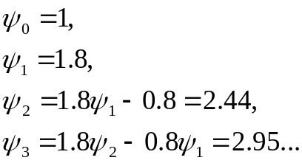 (8.25)
As new observation, naturally, we use the data, known in this point, as the forecast is retrospective. We make correction of the forecast according to (8.24):
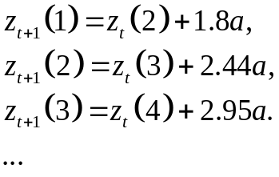 (8.26)
Results of this correction, in the presence of one or two new observations, are given in the figure 8.3.
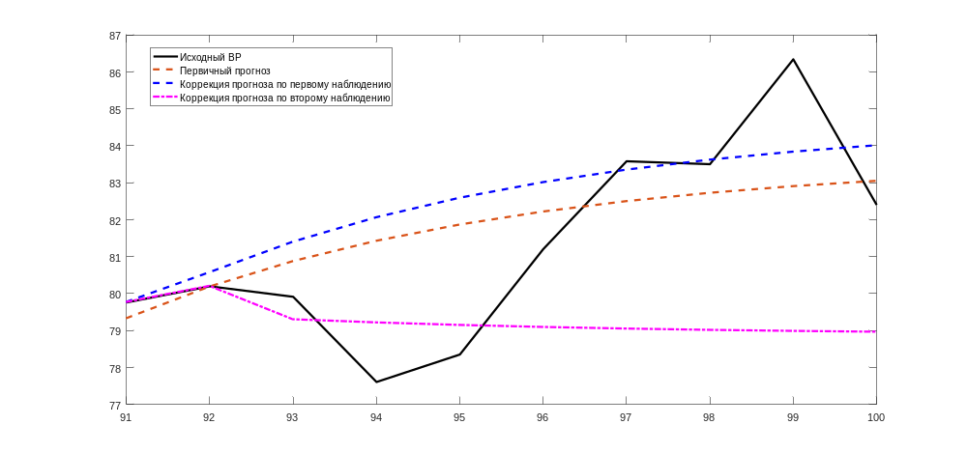
Figure 8.3 – Retrospective forecast and its correction for the first and second observations
Apparently from the figure 8.3, results turned out quite interesting. Correction on one observation gives us approximately for 3% increased forecast accuracy that is insignificant, but nevertheless it is good. And here correction also on the second observation gave already absolutely other forecast – instead of the increasing trend, it turned out decreasing. It turns out, the forecast worsened after correction? Yes and no. The matter is that correction of the forecast guarantees improvement of forecast accuracy only on one step forward.
With increase in number of counting correction will not necessarily lead to more exact forecast in general because the scheme was under construction initially for increase in accuracy on one more next step. So to compare the corrected forecasts – it is not absolutely right. Here if to compare the 3rd step of the initial forecast, with second at a slow pace corrected on one observation and with first step on two observations, then, undoubtedly, correction of the forecast for two observations was the most exact. Thus, the scheme of such forecast on the basis of ARIMA and its correction at minimization of a root mean square error should be considered the short-term forecast.

Part 4. Estimation of the confidence interval for the forecast
As it was already discussed when forecasting trends, any forecast is not absolutely reliable, and, therefore, with some probability can deviate from the best value. To understand in what limits this deviation occurs at the set probability of this variation of the forecast, and confidential intervals are under construction.
Let's try to construct on the basis of determination of confidential intervals and the available schemes and the ARIMA models of forecasting assessment of confidential intervals at the set confidence probability (level).
Let's calculate the variance of the forecast error (8.10):
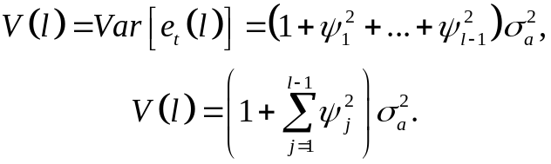 (8.26)
From the assumption that a submits to normal distribution, we receive that conditional distribution of probability of future value of process will be also normal with expectation value and standard deviation 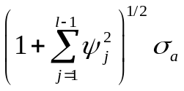.
To find the variance of this error (8.26) we lack parameter 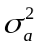, which, generally speaking, is hidden from the observer. But it still can be estimated.
A so-called residual data (discrepancies) is used for this:
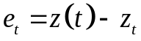 (8.27)
where 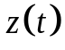 – initial observations of TS at the memont t, 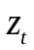 – observation from the constructed model at the time of t. In fact, a residual data is an error of adjustment of the real data to the selected model. Generally speaking, if the choice of model was carried out optimally, then a number of remaining discrepancies should have a normal distribution, so as it means that at creation of model we managed to divide completely into the deterministic and stochastic components.
But we will return to an assessment of and corresponding confidence intervals. Let's calculate the expectation value of a residual data and its variance:
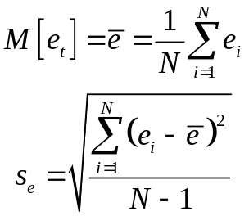 (8.28)
It appears the value can be approximately estimated with the help of variance of a residual data, at sufficient number of observations, taking into account correction factors. Together with this condition, approximate confidential intervals of the forecast will have an appearance:
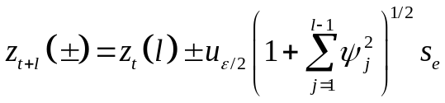 (8.29)
where 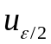 – a quantile on the level 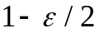 from standard normal distribution.
Upper and lower borders for the confidence intervals 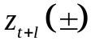from (8.29) correspond to (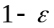)-% probabilistic limits.
We use expressions (8.29) and (8.28) for assessment of confidential intervals of the forecast for our example from the figure 8.1.
For the 50% limit the quantile is -0,674, for the 95% limit the quantile is -1,96. After calculation о the estimated variance and taking into account found weight coefficients, we receive the confidence intervals for the 50% limit:

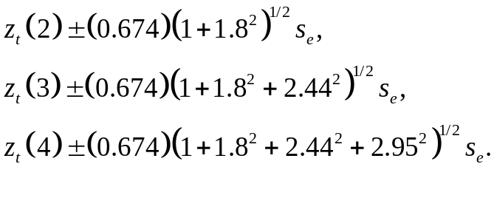 (8.30)

and then for the 95% limit:
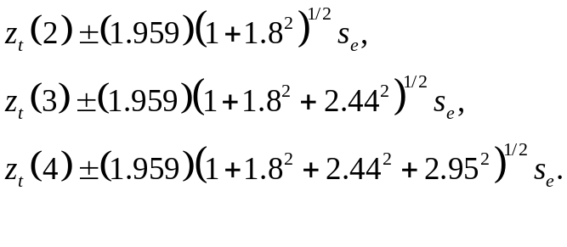 (8.31)
The final confidence intervals are represented on figure 8.4.
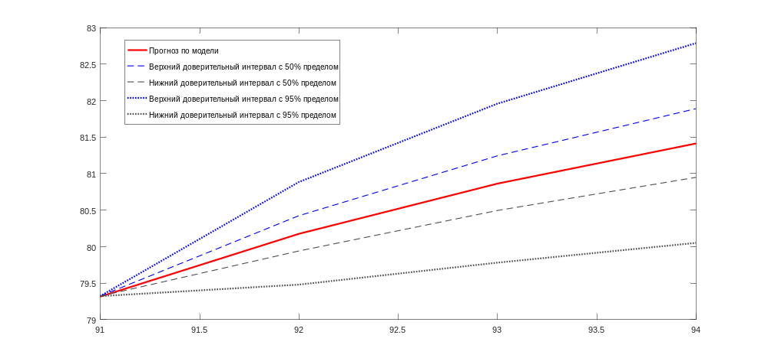
Figure 8.4 – Forecast confidence intervals

References

1. Chris Chatfield. Time-Series Forecasting. — Chapman and Hall/CRC; 1st ed. — 2000. — 280 p. ISBN 978-1584880639
2. Box G., Jenkins G. Time Series Analysis: Forecasting and Control. — 4th ed. Wiley. — 2008. — 784 p.
3. Karter J. Time series analysis with MATLAB. ARIMA/VARMAX/GARCH/GJR Models. Functions and Examples. — 2016. — 422 p. ISBN 978-1-539-54638-2

